**Ideation Phase**

**Define the Problem Statements**

|  |  |
| --- | --- |
| Date | 19 September 2022 |
| Team ID | PNT2022TMID01326 |
| Project Name | Emerging Methods for Early Detection of Forest Fires |
| Maximum Marks | 2 Marks |

**Customer Problem Statement Template:**

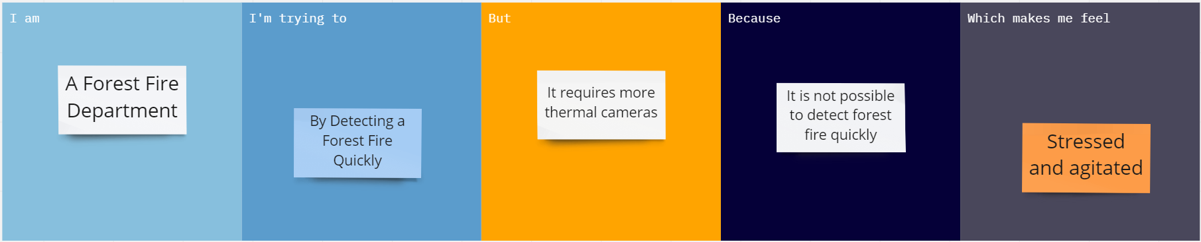

|  |  |
| --- | --- |
| **Problem Statement (PS)** | Forest fires are a major environmental issue creating economic and ecological damage while endangering human lives.  There are typically about 100,000 wildfires. It is difficult to predict and detect Forest fire in a sparsely populated forest area and it is more difficult if the prediction is done using ground -based methods like camera or video-based approach.Satellites can be an important source of data prior to and also during the Fire due to its reliability and efficiency. The various real-time forest fire detection and prediction approaches with, the goal of informing the local fire authorities |
| **IAM** | A Forest fire department |
| **I’m trying to** | Frequently monitor fire and make sure to prevent them from getting destroyed. Analyze data from various thermal camera |
| **But** | Requires a lot of thermal cameras for monitoring |
| **Because** | It’s really hard to cover large boundaries and monitorthem 24 hours a day |
| **Which make me feel** | Stressed and agitated about the forest are burning fast . |